Samantha Beik
Arch 0030: Art in Antiquity
September 29th, 2008

A Beacon Into The Past: The Etruscan Candelabrum

In ancient times, objects had power. Ancient peoples believed that their creations could serve a divine purpose, possess divine qualities, or connect humans to the land of the gods. The Mesopotamians built statues to pray to the gods in their place; they claimed that certain objects had “me,” the divine power that the gods possessed. The Egyptians believed that the pyramids served to connect the pharaoh’s spirit to the sun god Ra. In the ancient world, objects were not just inanimate: they interacted with their users, forging an intimate connection that very few in modern society would acknowledge.
During my visit to the RISD museum, I spent my time contemplating an Etruscan candelabrum from the 4th century BCE. It was made in order to perform an incredibly important job: it was a source of light for its users when otherwise they would have none. Interacting with people in this way, the candelabrum formed one half of a delicate power balance: it was fashioned by humans and expected to perform a task for them. It held its own power over those dependent on its function. But it was not crafted with only function in mind, having only the most basic elements that a candelabrum needs; the decoration and artistry of the candelabrum are of such detail that they caught, and kept, my attention. Not only is the candelabrum elegantly shaped, but there are many different artistic representations incorporated into its various parts.
The candelabrum is made up of three different parts, all of which are found in standard candelabra. The bottommost part is the base, made of three legs that support the rest of the structure. Stretching up from the base is the shaft, which accounts for most of the item’s height. The topmost part is the receptacle, also called the tray. The receptacle of this candelabrum has two parts. The first part is a dish; protruding vertically from this is the actual apparatus on which a candle or torch would have been placed in order to provide light. Altogether, the structure is about four feet tall.
The three legs of the base are quite sturdy, measuring perhaps an inch in diameter, until they widen to end in sculpted feet. The base itself is only eight or nine inches tall—quite short, compared to the shaft—but its width exceeds that of any other part of the structure: the three legs extend about eight inches each (at their farthest) from the center, meeting the surface on which they stand in the formation of the three points of an equilateral triangle. The width of the base is greater than the diameter of the receptacle, such that this diameter looks to be about two thirds the base’s width.
The shaft of the candelabrum is about two feet tall, a vertical pole, tapering so slightly as to be almost unnoticeable. With such a slight taper, the diameter of the shape is around an inch in diameter as it moves upwards (slightly more than an inch where it connects to the base, slightly less where it connects to the receptacle).
The receptacle is about ten inches tall overall, including both the actual tray and the area that holds the candle or torch. The shaft is separated from the receptacle by a dish; it is about five inches in diameter, an inch tall at its edges and two inches tall at its center. Another pole grows vertically from this dish for three inches, like an extension of the shaft, to support the candle-holder. The candle-holder has a circular base, about an inch and a half in diameter, from which four evenly-spaced branches expand upwards and slightly outwards. About five inches tall in total, these branches curve outwards to become nearly parallel to the floor at each of their ends.
The candelabrum is made of bronze; back in the 4th century BCE, it would have been a shiny, orange-brown color. Over the years, however, as the bronze (a copper alloy) was exposed to the air, its patina formed and it turned green. Now, behind the museum glass, it is mostly an olive color, with hints of dull orange-brown showing through in some areas. About two or three inches up the shaft, the surface of the metal changes from smooth and well-worked to rough. It almost looks like someone had polished the bottom four inches, but left the rest of the shaft to look somewhat rusty (the shaping of the rough surface looks as if there is a thin layer of dirt caked onto the shaft, though the roughness seems to be the metal itself and not a foreign substance). This roughness, beginning partway up the shaft and thus not affecting the base of the candelabrum, ends at the dish of the receptacle. The metal of both the dish and the candle-holder is smooth, like the metal of the base.
The difference in the metal’s texture is intriguing, especially since it only occurs over two feet, and in the middle of the candelabrum. Being in the middle of the object, it is unlikely that this part alone was left exposed over the years, affected by the elements while the rest of the candelabrum was under the ground. Then again, perhaps the item was not reconstructed until after it was found: the receptacle may have come apart from the shaft and been buried near the base, while the shaft was left above the ground to face the progression of years. Or perhaps the shaft of the candelabrum was finished hastily, without full attention paid to its polishing.
The base of the candelabrum is expertly sculpted. It attaches to the shaft with a tube shaped piece, which is flush with the shaft but curves outwards and downwards for two inches or so. Sculpted flame shapes circle the middle of this tube; one line of tiny metal balls is arranged along the curved-outward edge. Below that edge are the carved designs of plants. There is one bunch of upward-pointing leaves above each juncture where the leg leaves the top of the base, another situated in the exact middle of the space between each leg. Each bunch above the legs has two stems, one going to the left and the other to the right. These stems move diagonally downwards to the bunch of leaves in between the legs, which has a very short, vertical stem of its own. The three stems (the one coming diagonally from the left, the vertical one, and the one coming diagonally from the right) meet just under the bunch of leaves between each two legs to be tied together with some material; beneath these tied stems a downward-pointing bunch of leaves hangs. As the stems come out the other side of their tie, they curl, and from that curl they extend outward to travel along the legs of the base, which incline upwards at a slight angle for about 8 inches. At the end of this incline, the legs are sculpted to look like the feet of an animal. Tufts of hair have been sculpted on the downward-curving area of the leg; below that, the muscled ankle area leads to the paw, with toes, sharp claws, and the pads beneath its toes. Each paw rests on a small circular platform.
Immediately above the base, the shaft begins as a smooth cylinder. This part of the shaft is maybe two inches long, with horizontal lines separating this area into three sections. Above this piece, the shaft is fluted, with approximately 8 flutes carved. The flutes continue all the way up to the receptacle.
Teardrop shapes, with a double outline, are carved into the underside of the dish of the receptacle; they are arranged one directly next to the other, outlines touching, the curved, outside part of the drop towards the edge of the bottom of the dish. The outside end of each drop curves slightly upwards along the dish, to touch a set of horizontal lines encircling the dish along its edge. The extension of the shaft from the dish is smooth; however, it is as if three different areas of the pole have been pinched outwards, creating disk-like protrusions. Finally, the pole flattens and widens slightly into the surface that holds the candle or torch. Four half-inch-wide branches curve gently upwards and outwards from this base, their angling similar to that of the petals of a lotus flower. After three to four inches of vertical progression, the branches curve away from the center of the candelabrum, so that they end in a horizontal direction. As the branches become horizontal, they widen into plant-like shapes, with two leaves curling outwards.
In the 4th century B.C., this candelabrum would have been used to provide light to its creator (or to whomever it was given). Now, however, it is no longer a useful tool, but a piece of antiquity; it serves as a reminder of the power balance between objects and humans, between intention and results. The candelabrum was intended to give light, but if it were to fail, an unlucky person would be at the mercy of darkness. This candelabrum, then, was once powerful: just as it was shaped by the person who fashioned it out of bronze, it once shaped the lives of those around it. As an implement that, though inanimate, had so much control, looking at it and studying it can give insight into the lives of the people it served. All tools that have been used throughout history can give us this insight, by right of the power they once had. While humans eventually perish, objects do not; through the creations of those long ago we can see much of the life of ages past.

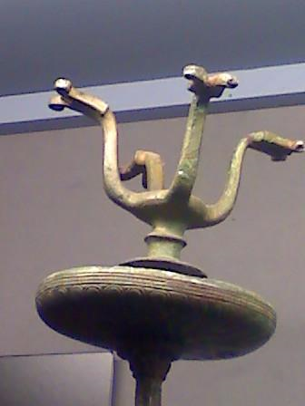
The receptacle of the candelabrum, with the dish and the apparatus for holding the light source.
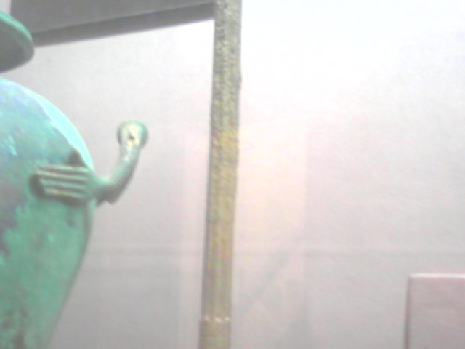
The fluted shaft of the candelabrum. Note the roughness starting partway up the shaft.

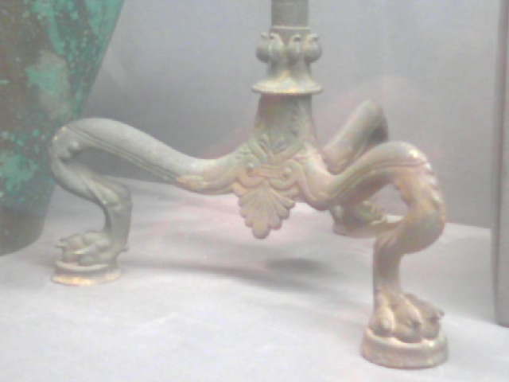
The base of the candelabrum.

