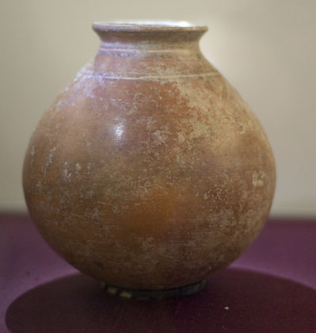
Michael Monn
ARCH1855 Practicum 4/13

During construction, several modifications were made to the proposed experimental procedure for the recreation of the vessel (pictured above). The original vessel was coil-built using red clay containing minimal added tempering material. The replica was planned to be wheel-thrown using Malone Red Clay in order to observe the significance of weakened zones located at the blending interfaces of the coils. The misalignments of the kick wheel’s axis of rotation would greatly increase the difficulty of fabrication due to the vessel’s large size and thin walls therefore the replica is slab-built rather than wheel-thrown. In order for the replica to conform to the dimensions of the original vessel, Grey Stoneware clay was selected instead of Malone Red clay due to general availability and superior plasticity. Due to the relatively low firing temperatures achieved in barrel kilns, full vitrification to a stoneware phase will not occur, and the fired vessel will retain earthenware-like qualities despite modifications to the type of clay used. Therefore, although the actual experimental reproduction diverged from both the planned construction methods and material, the goal of observing the significance of interfacial weak zones remains unchanged.
Procedure:
- Wedge two fist-sized quantities of Grey Stoneware clay
- Roll clay into ½” thick sheet
- Cut 2” dia. Base and 6”x6” square sheet for vessel walls
- Score and slip wall and base edges
- Attach wall sheet to base and blend edges. Use thin coils to reinforce joints
- Remove 3-2” long, thin wedges equally spaced around the top of the wall sheet in order to taper the top of the vessel inward
- Thin the walls from ½” to ¼” by drawing upwards from the inside of the vessel and forming the circular, gourd-like profile of the vessel.
- Invert the vessel and apply pressure to the inside of the base in order to round it
- Use a metal rib to remove excess clay from the interface of the base and walls, ensuring uniform wall thickness compared to the rest of the vessel.
- Cut a 1”x 6” sheet of clay to form the lip of the vessel. Reduce the thickness of this sheet by drawing it with wetted fingers before scoring it for attachment to the vessel.
- Attach the lip section and form it produce the necessary curvature and final radius.
- After allowing the vessel to become leather-hard, trim the lip to ensure symmetry, and apply a paddle and anvil technique in order to ensure uniform wall thickness and vessel curvature before firing.

