Peter Hatch and Susan Herringer Week 8 Practicum
Part I: Ceramic Manufacture and Materials Science
The Acoma Pueblo bowl is approximately a foot in diameter. It appears to have been made in a similar fashion to how Maria Martinez constructed the bowls in the documentary video that we watched. The bottom portion was likely a piece of slab that was pressed into a circular form/mold. The walls would have then been built up using coils. Once the form was constructed, the walls were likely thinned by turning and shaving. The surface was then burnished with a tool. The earthenware bowl has a red unglazed surface on the interior with a yellow slip/glaze in a linear design. A chip on the rim of the bowl exposes the cross-sectional color gradient of the vessel. The core is gray and transitions to yellow and finally red at the exterior. The outside of the vessel has a red glass on the bottom and a yellow glaze on the top portion; a black linear design was applied over the yellow glaze. Lastly, a clear glaze was applied. The cross-sectional color sequence provides details of the firing sequence and the application of the glaze. If the glaze was applied before the first firing, then the red-gray-red sequence would not be found, but rather a glaze-gray-red sequence (Figure 1).

Figure 1: The application in the glaze after the first firing would result in a color sequence (due to firing atmosphere) as seen in A. If the glaze was applied before the first firing, the color sequence would appear like that found in B. [adaptation from B. Velde and I. Druc, 1999, 124]

Therefore, there must have been at least two firings. The gray core of the ceramic may indicate either that (1) the interior was reduced (which would thus indicate at least 3 stages of firing); or (2) the ceramic was fired in an oxidizing atmosphere (red outside) and the core was just not oxidized. The latter option seems more likely. The thickness of the layers indicates the firing intensity, or length of time the ceramic was in the firing. A longer firing would appear in the cross-section as thicker oxidation layers as seen in Figure 2 (B. Velde and I. Druc, 1999, 123).
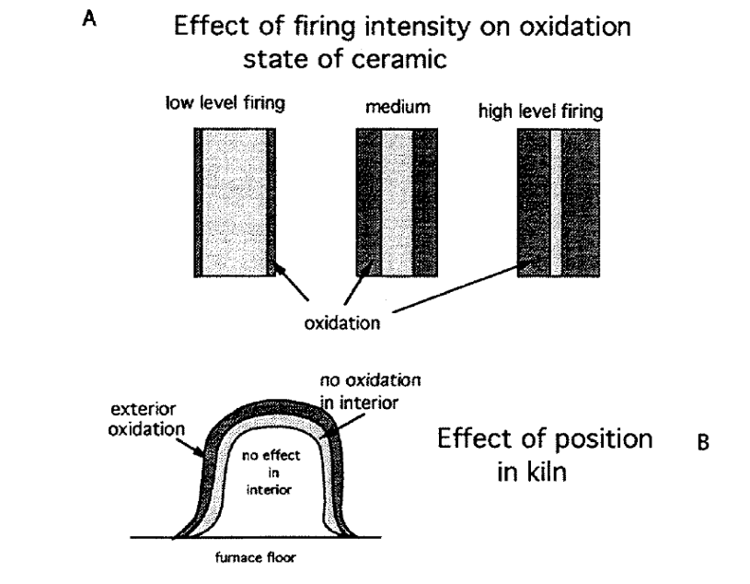
Figure 2 (B. Velde and I. Druc, 1999, 123): The thickness of the color layers gives an indication of the length extent of firing.
A medium level of firing is indicated from the equi-width of oxidized and unoxidized layers. The red color exhibited by the ceramic is due to oxidized ferric oxides; the red color is “generally not stable if fired to temperature above 1000ºC” (P. Rice, 2005). Therefore, the ceramic was likely not fired above this temperature. It is uncertain, however, if the clear glaze was applied before or after the second firing.
The ceramic does have temper inclusions. The advantages of temper include: (1) an increase in workability of the clay; (2) limit the extent of shrinkage in the drying and firing processes; and (3) provides thermal shock resistance. The vessel was shattered at some point and has since been glued back together. Two small pieces have been chipped from the rim; it is from these areas, that a more detailed description of the firing process was able to be discerned. From a materials science perspective, the damaged to ceramics occurs because of the low fracture toughness of the material. Fracture toughness is a property of a material that describes a material’s ability to contain a crack to resist fracture (in other words, the critical value of the stress intensity factor for which crack extension occurs). Fracturing is dictated by flaws – by voids, surface cracks, etc. Ceramics’ strength is commanded by the size of the flaw and the fracture toughness. The presence of temper, while it has its advantages, it decreases the overall strength of the vessel.
There are many ways an engineer may approach the study of archaeological ceramics. An engineer may study the clay structure (XRD) and temper (i.e. petrographic analysis) for firing temperature and atmosphere conditions. He may try to reproduce the material and further study the effects of such things as firing temperature and temper inclusions on crack propagation and toughness. Materials science may offer key information on technological choice.

Part II. Social and historical context
This pot is labeled as being from Acoma Pueblo in western New Mexico, one of a string of diverse pueblos across the Arizona and New Mexico that make up an important part of the indigenous fabric of the Southwest, all of which have old and continuing pottery traditions. According to the Haak’u Museum website, the pueblo is among the oldest continually inhabited places on the continent, first settled around 1150AD (Haak’u Museum 2011). The dating on this pot is extremely uncertain. The Haffenreffer Museum’s own records describe it as an ethnographic object, manufactured and purchased between 1965 and 1969 before being donated along with a “gift of Navaho [sic.] textiles, Pueblo pottery, and Southwestern jewelry” in 1975” (Haffenreffer Museum 2011). However, the fact that this is a shattered and refit piece (making it less valuable as an ethnographic object made for use or sale) indicates that it might be from an archaeological site instead. If this is an archaeological artifact, it carries no information context and may have been looted for profit. As such, the label we were handed in class suggests its date as “Pueblo III or later” which encompasses literally the entire history of Acoma Pueblo from 1150 to present. On the other hand, the combination of a red base and a cream upper register under a clear glaze and a rough-textured red interior seems most analogous to a bowl viewable at http://www.matthewchaseltd.com/pueblopottery/mcpot.htm, which is dated to 1940 (Chase 2007).
A large round bowl like this one could have been useful for a variety of purposes such as serving, mixing--as with maize dough--or perhaps storage. There is no evidence of charring on the exterior to suggest that it was ever used as cooking ware. As far as its use in religious or ceremonial life, many ceramics directly associated with private religious life of the Pueblos are a secret and closed to outsiders as the kivas (underground chambers within villages) that those ceremonies take place in (Dillingham 1992, 73). Although this vessel is painted with a variety of colors, the design of the surface treatment is not particularly elaborate, fine, or even symmetrical when compared to other examples of Acoma pottery, such as the contemporary pieces at a Tuscon art dealer at http://www.canyonart.com/acoma.htm (Canyon Country Originals 2011). Therefore, although it had to be fired at least two times, the time labor investment that went into this design is probably lower and this piece would have been more utilitarian than prestigious.
Having archaeological context for this item might determine this for certain, or its association with ceremonial locations or objects might controvert the preliminary interpretation. For example, finding this piece broken in a midden deposit, perhaps with other daily objects like broken manos and metates (grinding implements) would make this pot easily interpretable as an everyday object from an Acoma household, discarded when it shattered. Analysis of residues, such as maize flour embedded in the pores of the interior, could support this interpretation. However, such distinction between the sacred and the utilitarian may be somewhat overwrought in the Pueblo context, since the potter’s art was widely respected as an “integral and even sacred part of daily life” (Dillingham 1992, 8). Besides, without archaeological context any interpretation is tenuous.

References
Canyon Country Originals. 2011. “Acoma Pottery.” Accessed 22 March. http://www.canyonart.com/acoma.htm.
Chase, Mattehew. 2007. “Historic Pottery.” Accessed 22 March. http://www.matthewchaseltd.com/pueblopottery/mcpot.htm.
Dillingham, Rick. 1992. Acoma and Laguna Pottery. Santa Fe: School of American Research Press.
Haak’u Museum. 2011. “Acoma History.” Accessed 22 March. http://museum.acomaskycity.org/acoma-history .
Haffenreffer Museum. 2011. “Complete Object Report 76-33.” Haffenreffer Museum Catalog.
Rice, P. 2005 Pottery Analysis: A Sourcebook. University of Chicago Press.

Velde, B. and I.C. Druc 1999 Archaeological Ceramic Materials: Origin and Utilization. Springer-Verlag Berlin Heidelbert.

