Ian Brownstein
2/8/2011
Practicum #1: Production Processes

- I choose a ceramic vessel from Italy used for everyday eating and drinking (Figure 1). The vessels color is split between two fairly homogenous sections: the upper portion of the vessel is a orange-brown fired clay color and the lower portion is a red-orange which may be the color the vessel was glazed or painted. The vessel has two identical handles of opposite sides of the container, which based on the containers size; indicate that they may have been used for holding the vessel so that it could be drunk. In terms of non-functional features, the vessel has three rings, which run around the circumference of the upper portion of the vessel in-between where the handles meet the container. There are also circular features coming out of organically patterned stands, which may be some sort of vegetal motif, which surrounds the lower half of the vessel. The vessel stands on a base, which comes out of the bottom of the vessel. The vessel also seems to be very well preserved, as there seems to be no interruptions in any aesthetic patterns or major fractures in the piece. The only signs of wear are a few chips missing from the upper rim of the vessel and the change in color which may indicate a wearing off of the potteries possible glaze or paint since its creation.
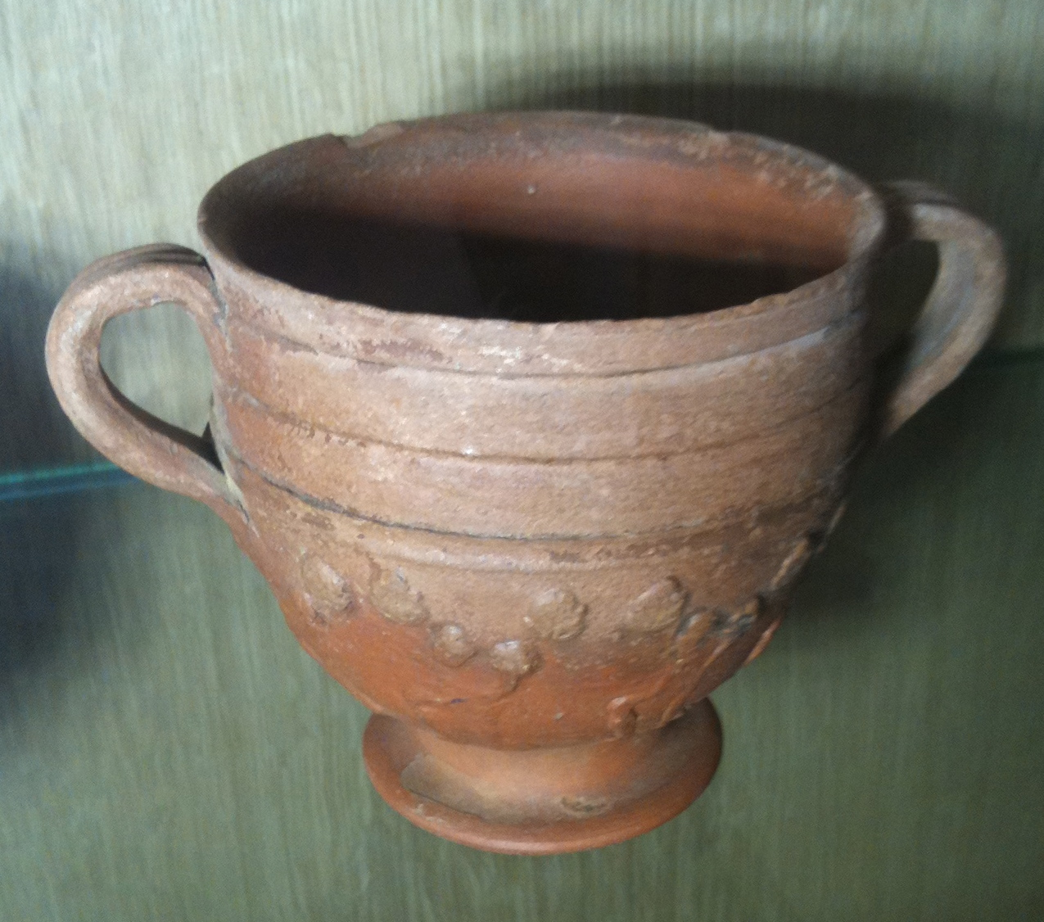
Figure 1
- Based on the uniformity in the rings around the vessel, the potteries interior, and the external symmetry of the vessel created with such a complex shape led me to believe the vessel was made on the wheel. If this is so the handles were added on after the container was taken off the wheel, which is also indicated by the attachment points of the handles to the vessel. There are also signs of glaze or painting after the firing of the vessel based on the regions of color on the vessel. Direct variables in the firing of the clay include the fuel used in firing and the clay used to make the pottery. Indirect variables would them be temperature, gases produced in the firing, and the homogeneity of the clay material, which can greatly affect the success of the firing.
- The vessels chipped rim, non-uniform discoloration on the interior of the vessel, and its slight lean off vertical all may be signs of imperfect craftsmanship. The chipped rim most likely occurred over time when or after the vessel was put out of use, assuming it was used for a functional not aesthetic purpose. The non-uniform discoloration on the interior of the vessel is more specifically a long streak of the upper vessel color spilling into the lower portion of the vessel, which may be a sign of imperfections in the glazing process. Another possible answer is that this is a result of uneven wear but based on the strong drip-like appearance of the flaw it is most likely a result of a post-firing process. The slight lean in the vessel is mot likely a result of the removal of the clay of the wheel where, if handled improperly, can cause deformation before the clay is fired.
- Archaeometric techniques could answer question about the vessels flaws as well as give insight into how the vessel was crafted. Finite element analysis (FEM) could give insight into the creation of the vessel and how human interactions with it before firing may have caused deformations such as its off vertical lean. Mass spectrometry could reveal the composition of the clay, allowing us to refine where in Italy the clay may have come from, and the coloring pigment to determine if the vessel was glazed, painted, or both which would allow us to have a more educated understanding of the possible drip mark and the layered coloring of the vessel. Thermo Gravimetric Analysis (TGA) or Differential Thermal Analysis (DTA) could provide insight into the temperature at which the clay was fired to give insight into the firing environment of this and other similar vessels. Thermoluminescence could help determine the age of the vessel, which would allow us to put the pottery in context of an era of Italian culture in the location, determined using mass spectrometry, which will help determine if the pot was used functionally or for decoration. Computer aided tomography could help determine the process by which the vessel was created can help confirm that the handles was attached post-wheel and other hidden steps in the vessels creation.

