Max Monn
ARCH1855 Practicum: Production Processes

- I chose to analyze the manufacturing process of a small ceramic vessel from Italy, which was used for everyday food and drink purposes. The vessel, shown below, has an approximate height and maximum diameter of 5”, and is supported by a ~2.5” diameter base. The walls appear to have a nearly uniform thickness of ~1/4”. The vessel is inhomogeneous in coloration, the upper portion dominated by the light brown hues of the ceramic material and the lower half coated with a rust-colored paint or glaze. Similar red tones can be seen around the lip and inside of the vessel. The non-uniform nature of the coloration on the lip suggests either heavy use during its life cycle, or discoloration due to staining. Two 1.5” diameter handles are attached on opposite sides of the vessel. Their size and thickness suggests that they were functional rather than purely decorative. The only aesthetic relief present on the vessel consists of a diamond shaped pattern of small, raised dots located midway up the vessel’s outer walls.
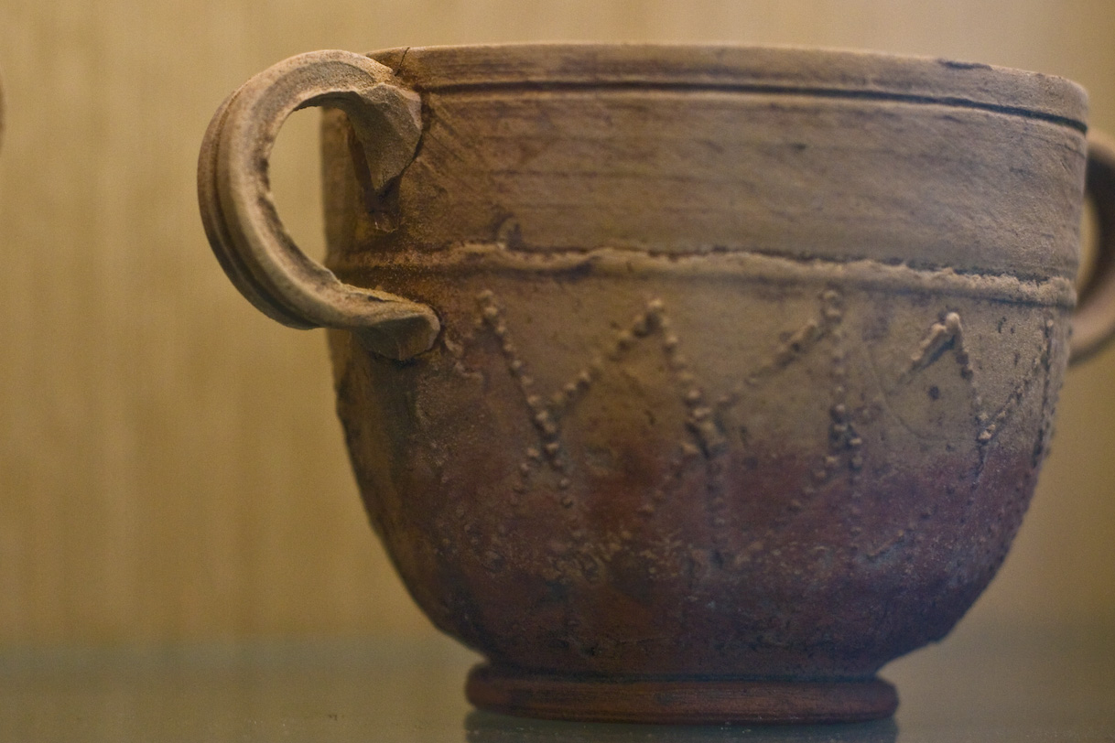
Figure 1: Front View
The coarsely grained ceramic is very well preserved, as evidenced by the lack of erosion of the surface reliefs. The edge of the upper lip has experienced minimal blunting, and striations on the inside of the vessel caused by manufacturing are still visible. Although the vessel has been affected very little by erosion, the upper half has been fractured at the lip (Fig 2).
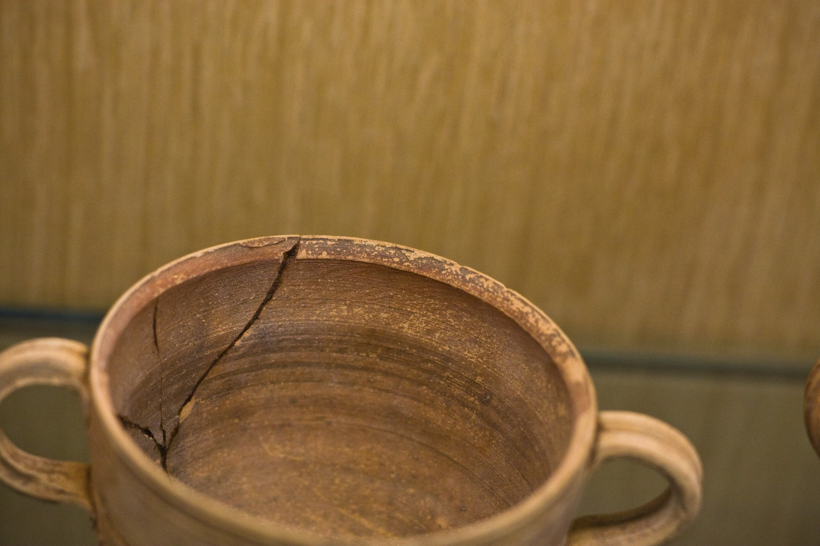
Figure 2: Top View
Finally, there are signs of erosion around the joints where the handles are connected to the body of the vessel.

- The high level of rotational symmetry, and circumferential surface striations suggest that the body of the vessel was formed on a wheel. The erosion of the joints connecting the handles to the vessel body indicates a structurally weak, surface-level connection of the handles. Additionally the handles may have been formed around some type of cylinder, as is suggested by their flat interiors and similarity in size. The rotational asymmetries visible at the bottom of the vessel body indicate deformations that occurred after the body was removed from the wheel. This suggests that the base of the vessel was either attached or sculpted after removal from the wheel. Indirect variables that would have affected the creation of the vessel include: firing temperature, exposure to gases/foreign materials during firing, and composition of the ceramic material. These indirect variables are controlled by what material the potter incorporates into the clay, and what type of fuel is used when firing the vessel. The aesthetics of the vessel are determined by the way that the potter works the clay, in this case, a wheel.

- The asymmetry of the vessel’s base, and the large fracture at the lip of the vessel are potential suspects for crafting flaws. The latter could have been caused by stress concentrations due to an inclusion or air pocket. Although the latter may have been caused by the presence of an air pocket or inclusion, internal flaws would have likely resulted in fracture upon initial firing of the vessel. The asymmetric deformations located on the vessels based were most likely caused by the modification of the base or improper handling after removal from the wheel.
- Using various methods of archaeometry, it is possible to confirm hypotheses made during the visual examination of the vessel. It is uncertain whether the red coating visible on the outside of the pot is paint, applied post-firing, or a glaze baked onto the vessel. Furthermore, the darkening of the lip may have been intentionally painted/glazed or caused by oxidation of metals found in the clay. Analysis using mass spectrometry would allow us to deduce the chemical composition of these coating and consequently reveal the means of application/creation. 3D Laser Scanning or X-Ray Tomography would provide more information about the construction/assembly of the vessel. Virtual volumetric analysis and curvature analysis of the handles would reveal if they were formed using a dowel or cylinder as a template. Finite element modeling would be used to address the origin of the asymmetric deformations visible near the base of the vessel.

